**NATRAJ ACADEMY OF PERFORMING ARTS PVT. LTD.**

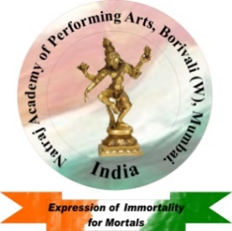

***Govt.Regd. No :* U92412MH2012PTC231936**

**Member of the International Dance Council**

**(CID), UNESCO. Membership No: (22188).**

***Director : Ms.Ashlesha U.Velhal.***

**Membership No: (29418)**

PHOTOGRAPH

ADMISSION FORM

1. FULL NAME : ( Mr/Mrs/Mst/Ms.) ___________________ ________________ ________________

SURNAME NAME MIDDLE NAME

2. DATE OF BIRTH : ________________AGE : ________ yrs.

3. GENDER :______________. EMAIL :___________________________________________________

4. EDUCATION QUALIFICATION: ______________________________________________________

NAME OF SCHOOL / COLLEGE:_______________________________________________________-

5. RESIDENTIAL ADDRESS: ­­­­­­­­­­­­­­­­­­­__________________________________________________________

__________________________________________________________________________________

6. TELEPHONE NO : ( RES ) : ______________________(MOB) :_____________________________

7. PREVIOUS DANCE QUALIFICATION:__________________________________________________

8. ANY AWARDS RECEIVED IN THE FIELD OF DANCE : ___________________________________­­­­­­­­

9. JOIN THE INSTIUTION FOR ( TICK YOUR OPTION)

* BHARATNATYAM DANCE (0-13 Years Course). Yes / No.
* KATHAK DANCE (0-13 Years Course). Yes / No.
* INDIAN FOLK DANCES (0- 8 Years Course). Yes / No.
* BOLYWOOD DANCES (Solo / Group). Yes / No.

10. ARE YOU INTERESTED TO PERFORM IN PROFESSIONAL SHOWS IN

(PLEASE TICK YOUR CHOICE) :-

* MUMBAI. / OUT OF MUMBAI. / OUT OF INDIA.

___/____/_______ ____________

DATE OF JOINING SIGNATURE

DRESS CODE : -

Comfortable Loose Fitting Clothes (Uniform: Red Salwar , White Kurti & Red plain Dupatta).Tight Fitting dresses & Western dresses are strictly not allowed for learning classical dances.